Assessment Schedule – 2013

Music: Demonstrate aural understanding through written representation (91275)

Evidence Statement
Question | Achievement | Achievement with Merit | Achievement with Excellence
ONE | Chord Recognition
(a) | There are 12 chords and two cadences to be identified.  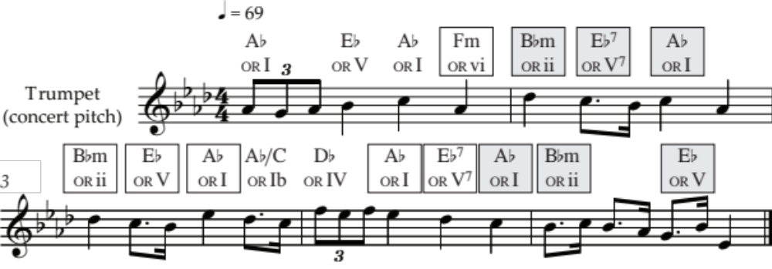  Cadence ①: Perfect  Cadence ②: Imperfect
(b) | There are 12 chords and two cadences to be identified.  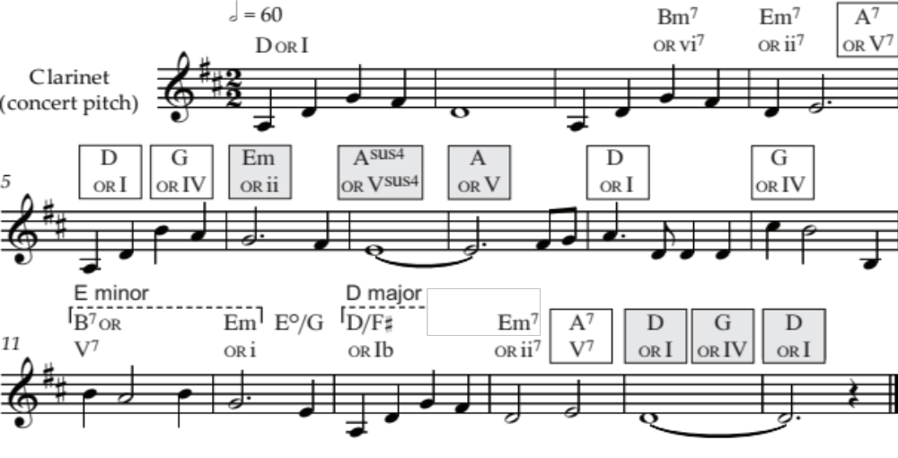  Cadence ①: Imperfect  Cadence ②: Plagal

N1 | N2 | A3 | A4 | M5 | M6 | E7 | E8
Identifies ONE chord (of 12) in isolation in either part of the question. | Identifies TWO chords (of 12) in isolation in either part of the question. | Identifies FOUR chords (of 12) in isolation in either part of the question. | Identifies FIVE chords (of 12) in isolation in either part of the question. | Identifies TWO progressions of TWO adjacent chords from across both extracts. | Identifies THREE progressions of TWO adjacent chords from across both extracts. | Identifies TWO cadences | Identifies THREE cadences
 |  |  |  |  |  | AND  For ONE cadence, identifies all three highlighted chords. | AND  For TWO cadences, identifies all three highlighted chords.
N0= No response; no relevant evidence.
Question | Achievement | Achievement with Merit | Achievement with Excellence
TWO | Melodic and Rhythmic Dictation
(a) | There are six contours / patterns, and two phrases to transcribe.  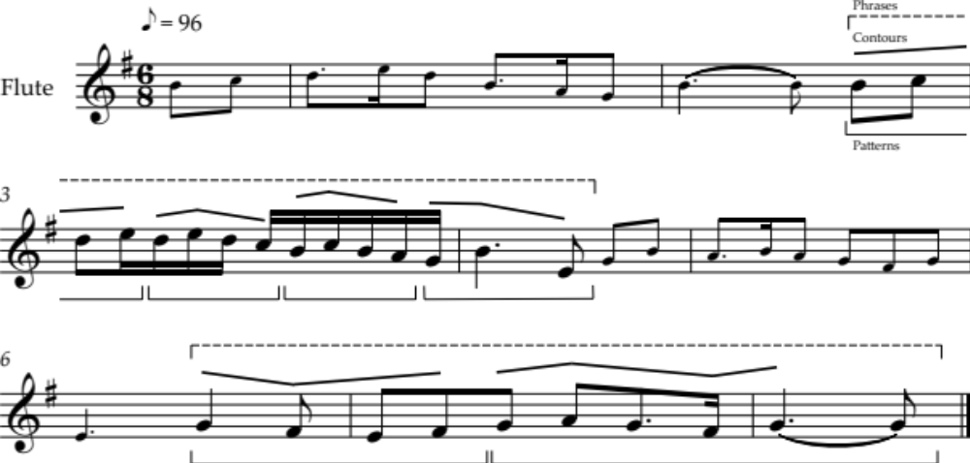
(b) | There are six contours / patterns, and two phrases to transcribe.  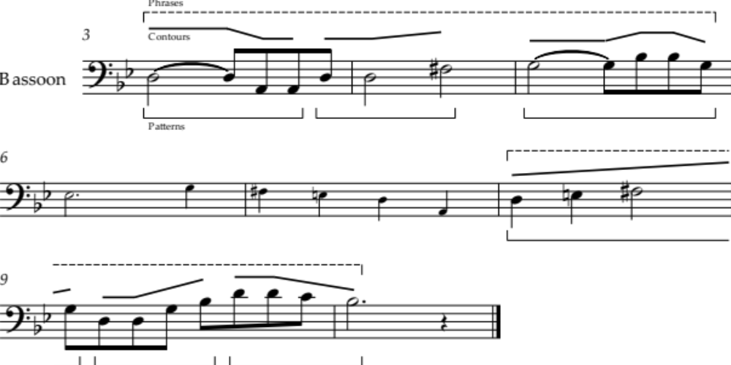
 | Note that accurate identification of a contour requires that its first and last pitches are appropriate in relation to the pitches that precede and follow it.

N1 | N2 | A3 | A4 | M5 | M6 | E7 | E8
Identifies ONE contour (of 6) in either part of the question. | Identifies TWO contours (of 6) in either part of the question. | Identifies THREE contours (of 6) in either part of the question. | Identifies FOUR contours (of 6) in either part of the question. | Accurately transcribes THREE (of 12) patterns. | Accurately transcribes FOUR (of 12) patterns. | Transcribes TWO (of 4) phrases accurately, with allowance for TWO inexact pitches or rhythms. | Transcribes THREE (of 4) phrases accurately, with allowance for TWO inexact pitches or rhythms.
N0= No response; no relevant evidence.

Question | Achievement | Achievement with Merit | Achievement with Excellence
THREE | Elements and Expressive Features
(a) (i) | Identifies the musical element contributed by any TWO instruments, eg: | Describes how the element is used by TWO instruments, eg:
 | Snare drum  - rhythm | Snare drum  - plays on beats 2 and 4 of each bar
 | Guitar  - melody | Guitar  - plays a 2-phrase tune
 | Piano  - harmony. | Piano  - plays both bass and chords.
(ii) |  | Identifies the bar of the melody used as the melodic basis for the chorus melody:  - marks ‘✗’ above the last (second-time) bar.
(iii) |  |  | Notates the first bar of the chorus:  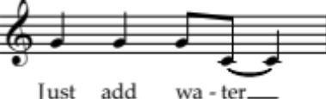
(iv) | Describes the role of the lead singer in the chorus:  - sings the melody / hook line (which is repeated once).
(v) |  | Describes TWO roles of the backing singers in the chorus, eg: | Describes in detail TWO roles of the backing singers in the chorus, eg:
 |  | - they provide the harmony / backing vocal | - they provide the harmony / backing vocal, singing together in thirds
 |  | - they echo (the words) of the lead singer. | - they echo (the words) of the lead singer at the beginning (“just add water”) and end (“dissolve”) of each phrase.
(vi) | Identifies ONE untuned percussion instrument used in the outro:  - tambourine  - (egg) shaker / maraca  - kick / bass drum.
(vii) |  |  | Describes in detail the role of the piano at the beginning AND the end of the outro, eg:  Beginning  - plays bass and chords (as in the introduction), and melody  End  - plays broken chords / arpeggios (chords I and IV).
Question | Achievement | Achievement with Merit | Achievement with Excellence
(b) (i) | Identifies the solo instrument:  - violin. | Identifies AND describes TWO instrumental techniques used by the soloist, eg:  - arco – using the bow  - double stopping – playing two notes together  - glissando – sliding from one note to another.
(ii) | Identifies the instrument playing the main theme OR the percussion instrument:  Main theme  - oboe  Percussion  - temple blocks / woodblocks / coconut shells.
(iii) |  | Describes ONE way the melody / pitch is different in the restatement of the theme, eg:  Melody / pitch  - the melody is (doubled) an octave higher  - a countermelody is added. | Describes ONE way BOTH the texture and instrumentation have been developed in the restatement of the theme, eg:  Texture  - polyphonic – there are now two melodies with independent rhythms  Instrumentation  - piccolo doubles the oboe playing the main theme  - French horn (accept trombone) plays the countermelody.
(iv) |  |  | Describes ONE way that each of TWO elements / features is different from earlier extracts, eg:  Tempo  - slower  Melody  - countermelody (from earlier extract) has become the melody  - trombone instead of French horn  Accompaniment  - in the upper register (upper woodwind and celeste instead of temple blocks and strings)  - tuned instruments instead of untuned percussion  - decorated with mordents / grace notes  Articulation  - smoother / legato (both melody and accompaniment)

N1 | N2 | A3 | A4 | M5 | M6 | E7 | E8
ONE piece of evidence at Achievement level. | TWO pieces of evidence at Achievement level. | THREE (of five) pieces of evidence at Achievement level. | FOUR (of five) pieces of evidence at Achievement level. | THREE (of five) pieces of evidence at Merit level. | FOUR (of five) pieces of evidence at Merit level. | THREE (of five) pieces of evidence at Excellence level. | FOUR (of five) pieces of evidence at Excellence level.
N0= No response; no relevant evidence.

Judgement Statement
 | Not Achieved | Achievement | Achievement  with Merit | Achievement  with Excellence
Score range | 0 – 8 | 9 – 13 | 14 – 19 | 20 – 24

